JAWAHAR NAVODAYA VIDYLAYA AMARKANTAK ANUPPUR M.P.
FA IV (FEBRUARY 2011-12)
SCIENCE AND TECHNOLOGY (THEORY)
M.M. 40 TIME 1 ½ HRS.
INSTRUCTION:
- Question Paper is divided into 3 parts, Part A Chemistry (18 Marks) Part B Physics () Part C Biology
- All the questions are compulsory and to be performed Section wise
SECTION A (CHEMISTRY)
- 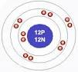
Calculate Atomic number and Mass number of the given element.
Identify the element and write the symbol of the element (2 Marks)
- What are isotopes? Give two application of Isotopes. (2 Marks)
- Compare the properties of electrons, protons and neutrons. (3 Marks)
- 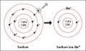
Na⁺ has completely filled K and L shells. Explain.
(2 Marks)
- A scientist performed a experiment to determine the structure and designed the following setup:
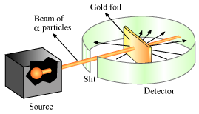
Name the scientist. Explain the experiment and write the conclusion and draw the atomic model on the basis of his theory.
(5 Marks)
- Write the formulae of the following compound:
- Sodium Phosphate ii. Magnesium Nitrate
- Draw the atomic model of 